**Executive Summary**

## Working Sm@rt with OneNote

**Current Situation**

**Effective collaboration and communication is key to Personal Effectiveness and Team Development**. For complex organisations with geographically dispersed teams it is recognised that effective collaboration, communication, information management and information sharing is critical for effective performance and productivity. It is also recognised that the organisation has provided certain technology tools to assist, namely Microsoft OneNote, but that this tool is currently under utilised.

**Proposed Solution**

The *Working Sm@rt with OneNote* programme from Priority Management is a highly effective training programme focussing on processes and best practices to foster effective collaboration and communication, and how these processes can be supported and implemented using OneNote.

The course will allow team members to enhance information management and collaborative communication regardless of geographical location or time zone.Established for over 40 years,Priority Management is a global leader in the development of highly practical training programmes that integrate best practice self-management strategies with the technology to support it.

The key to success lies in the ability for teams to work together without the constraint of being together. Whether the challenge is virtual teams where geography is an issue or just the reality that team schedules do not always allow for face to face meetings, we must be able to overcome this constraint. Now it is possible to collaborate in a way that maximises flexibility and minimises the number of places that you need to look to find key information or data. You will be able to find everything you need for a specific project or subject using your consolidated OneNote notebook.

**The WorkingSm@rt® Method.**

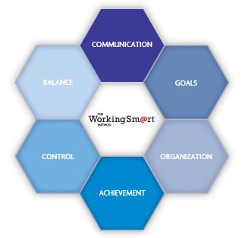WorkingSm@rt® is a flexible and practical combination of behaviour changing methods, best practice tools and process that can transform the way you and your teams work. With the WorkingSm@rt method you will gain control over your day, find balance, reach your goals and focus on the tasks that are important to you and your company.

WorkingSm@rt+OneNote provides individuals and teams with improved skillsets around organisation, communication, collaboration, control and balance.

Easily applied and simply sustained, the WorkingSm@rt method can give lifelong benefits to individuals, teams and entire organisations.

**Program Outline**

## Working Sm@rt with OneNote

The **Working Sm@rt with OneNote** workshop from Priority Management has been developed to help you and your team improve the effectiveness of collaboration, sharing, meetings and communication, through a series of processes and best practices supported by the effective use of Microsoft OneNote.

**Effective Collaboration & information management**

Understand the key issues and best practices that will optimise information management and effective communication and how this can help to significantly improve individual and team performance, productivity and effectiveness.

**Information management best practices**

Identify the best practices in information management for capturing, organising, finding, centralising, sharing and storing information.

Determine how closely you currently follow these best practices and where improvements can be made.

**Getting started with OneNote**

Understand and learn basic OneNote concepts. Understand the structure of OneNote notebooks.

Learn how to create, save, and share a notebook. Learn how to use a OneNote notebook to support a project or a meeting.

**Taking and creating notes**

Learn how to:

Insert notes in sections and pages

Create and use templates to facilitate individual and team note-taking

Insert different types of information into a notebook

Manage space in pages

**Working as a team with shared Notebooks**

Using OneNote in a docked session to easily link information from an application or from the web.

Managing shared notebooks

Working as a team with shared notebooks

Managing different editions of a notebook

**Linking, tagging & locating notes**

Linking multiple pieces of information

Tagging information

Retrieving information using links and tags

**Integration of OneNote with Outlook**

Use OneNote to support and enhance your daily activities in Outlook, especially with calendar, meetings, email and tasks.