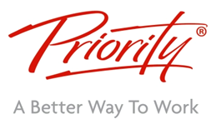



## WorkingSm@rt with Outlook – Overview

**Would you like to save time, get more of the right things done and reduce stress?**

The ***WorkingSm@rt*** ***with Outlook*** time and workload management programme from Priority Management is a personal and team effectiveness course which provides significant benefits to partners, directors, managers, teams and individual contributors to help you improve planning processes, focus on priorities, control your time and **increase productivity** whilst significantly reducing stress and improving work/life balance. On average, our delegates report average time savings of **of nearly an hour a day as a result of this course.**

**Business Challenges**

Whether working from the office, from home, or a hybrid, maximising our productivity and utilising work hours effectively is a challenge many of us face. The increasing volumes of email and other electronic messaging can be difficult to manage whilst keeping focussed on our most important work. Meetings, deadlines and business pressures challenge our ability to get work done and can cause stress and issues around work/life balance. Research has shown that significant portions of our working hours are spent on low-value tasks, leading to dissatisfaction and a mismatch between our activity and our key goals.The WorkingSm@rt programme helps participants to address these and other issues and optimise their workplace effectiveness. The programme provides the knowledge, skills and competencies to significantly improve personal and team productivity.  It ensures that participants can adapt their working practices to:

**Delegates will learn to:**

* Always focus on activity that adds value
* 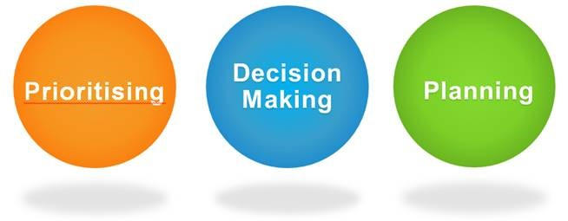Plan and keep control of time, workloads and tasks
* Turn intentions into actions
* Control email and distractions to remain pro-active
* Effectively prioritise, regardless of high volumes of digital information and communication
* Optimise the impact of your electronic communication
* Manage expectations with regard to delegated work
* Easily and quickly file and find information
* 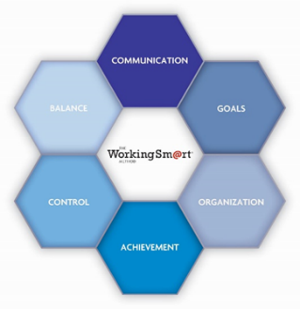reduce stress and improve work-life balance

The programme is delivered as an interactive, instructor-led workshop, combining the processes and best practices associated with effective management of work, with the tools available to delegates within MS Outlook.  It is this powerful combination that results in sustained behavioural change and significant improvements in individual and team productivity and effectiveness.  In global evaluation data collected from more than 32,500 delegates who have taken this programme, **participants report average time gains of more than 54 minutes per day, per person.**

**Programme Format**

The programme is delivered online as a half-day, (3.5-hours) or 2 x half-day, instructor-led workshop. The maximum class size is 20 delegates and the workshop is supported by a 1-hour group follow-up coaching session between 2 and 3 weeks after the workshop.





**Programme Outline**

## WorkingSm@rt with Outlook™

|  |  |
| --- | --- |
| **The Productivity Process**  Understand the formula for improving workplace performance and productivity and the vital role of integrating processes, skills and tools. You will learn key techniques for working more effectively, both individually and in teams.  **Priority Planning**  Learn simple but effective planning processes and discover how you can become more strategic in your choice of activities. You will be able to consistently link activity to key goals and objectives and you will reduce stress and improve your work/life balance.  **Managing Digital Information**  Cut through information overload and establish Email best practices to clear your Inbox. Optimise your decision-making process with Priority Management’s 4D formula and discover how to easily track and manage email follow up for yourself and for work handed over to others. We will show you how to develop a simple system for safe storage and retrieval of messages. You will be able to stay focused on your priorities, regardless of your Email volume, and will feel more in control.  **Staying Focused on Activity That Adds Value**  Create a focused and manageable workload by consistently prioritising your work effectively and improving your management of activities and tasks. You will learn simple but effective processes for differentiating between ‘urgent’ and ‘important’ and for always knowing exactly what to do next.  **Managing Commitments**  Learn how to manage your schedule effectively and quickly access information required for meetings. You will become more proficient in managing your  time and will learn how to use Outlook as a ‘work planner’, to help you maintain control over your | activities and schedule, regardless of competing priorities and demands on your time.  **Improving Communication**  Keep track of your communications with others and ensure that expected responses are monitored and followed-up. We will show you how to capture, safely store, and instantly retrieve information when required. You will learn best practices to improve the quality of electronic communication, including email and instant messaging, and to manage expectations around responses.  **Teamwork**  Learn how to use Outlook for effective communication, delegation, assignment and project execution. We will help you create ‘rules of engagement’ for your team or organisation to agree and manage expectations. Managing and analysing team or project-related work will become a fast and simple process and you will be able to quickly review who owes you information and when it is due.  **The Outlook Business Solution**  Understanding what is available in the Outlook ‘toolbox’ and learn how to use the functionality of Outlook to support best practices for managing your commitments, communications, tasks, meetings and planning.  **Putting it into Practice**  The processes and best practices from the *Working Sm@rt* course are extremely practical and realistic and you will be able to deploy the new techniques learned as soon as you return to your desk. There is no delay in implementation and maximum behavioural change can be achieved. |

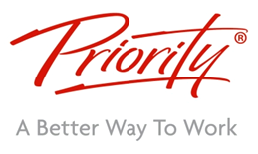

## Table Description automatically generated with medium confidenceMeasurable, sustainable outcomes

Data collected up to the end of 2022 via online evaluations sent to delegates approximately two months after they have attended a *Working Sm@rt* workshop.